EAST KEAL PARISH COUNCIL  
Half Yearly Internal Audit Report (covering 1/4/15 to 30/09/15)

The purpose of the half yearly audit is: -

1. To check the accuracy of the accounts and highlight any discrepancies.
2. To look at financial presentation and procedures relating to the accounts and make recommendations where I think improvements could be made.
3. To check that you are operating in accordance with your Financial Policy documents and with the Joint Practitioners Advisory Group’s document “Governance and Accountability” for Local Councillors.

**ACCOUNTS**

I have examined the accounts for the above period and I confirm that they have been properly prepared and are a true representation of the records made available to me.

**Financial Recommendations**

Regarding your financial procedures I have two recommendations to make and they are: -

1. Councillors should ensure that cheque stubs are signed by the two councillors who signed the cheque. This has not happened for cheque Numbers 379 to 389.
2. Councillors should ensure that the payee written on the cheque stub is exactly the same as the payee written on the cheque and any Invoice provided.

**Other Recommendations**

1. The Parish Council Plan for 2015 to 2019 has not yet been published.  
   A Parish Plan is essential (however modest) to enable councillors to track their progress against the Plan and to advise Parishioners what they hope to achieve in the period.

A £50 grant was made to East Keal Parochial Church Council to assist in maintenance with the Church grounds.

* The letter of thanks should have included a statement detailing what the money was used.
* The letter of thanks should have been written and signed by either the Chair or Treasurer of the EKPCC and not the Secretary as there is a “Conflict of Interest” with the role of East Keal Parish Clerk.

Signed 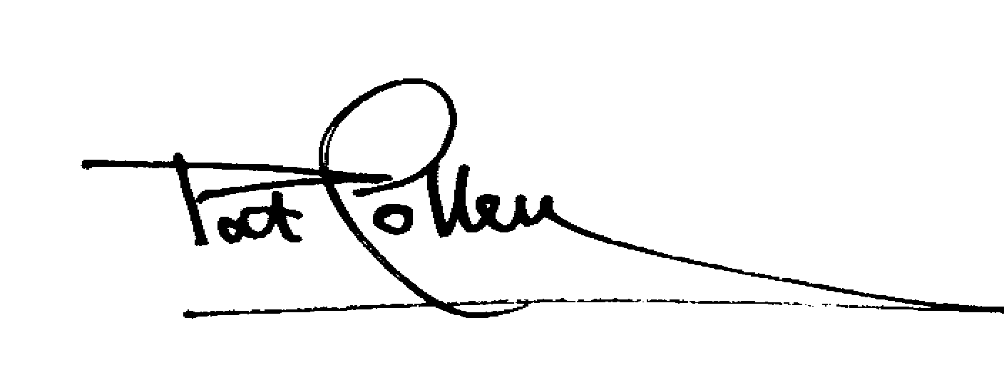 17th November 2015